**DBMS LAB ASSIGNMENT – 4**

**BY: GROUP 12**

**JAGADEESH C (18BCS033)**

**DARSHAN R P (18BCS023)**

**ARUN KUMAR S M (18BCS013)**

**G NIKHIL KRISHNA (18BCS030)**

**KANCHARLA GIREESH KUMAR (18BCS035)**

**KUMPATLA SAI GANESH NAIDU (18BCS044)**

**Main Table:**

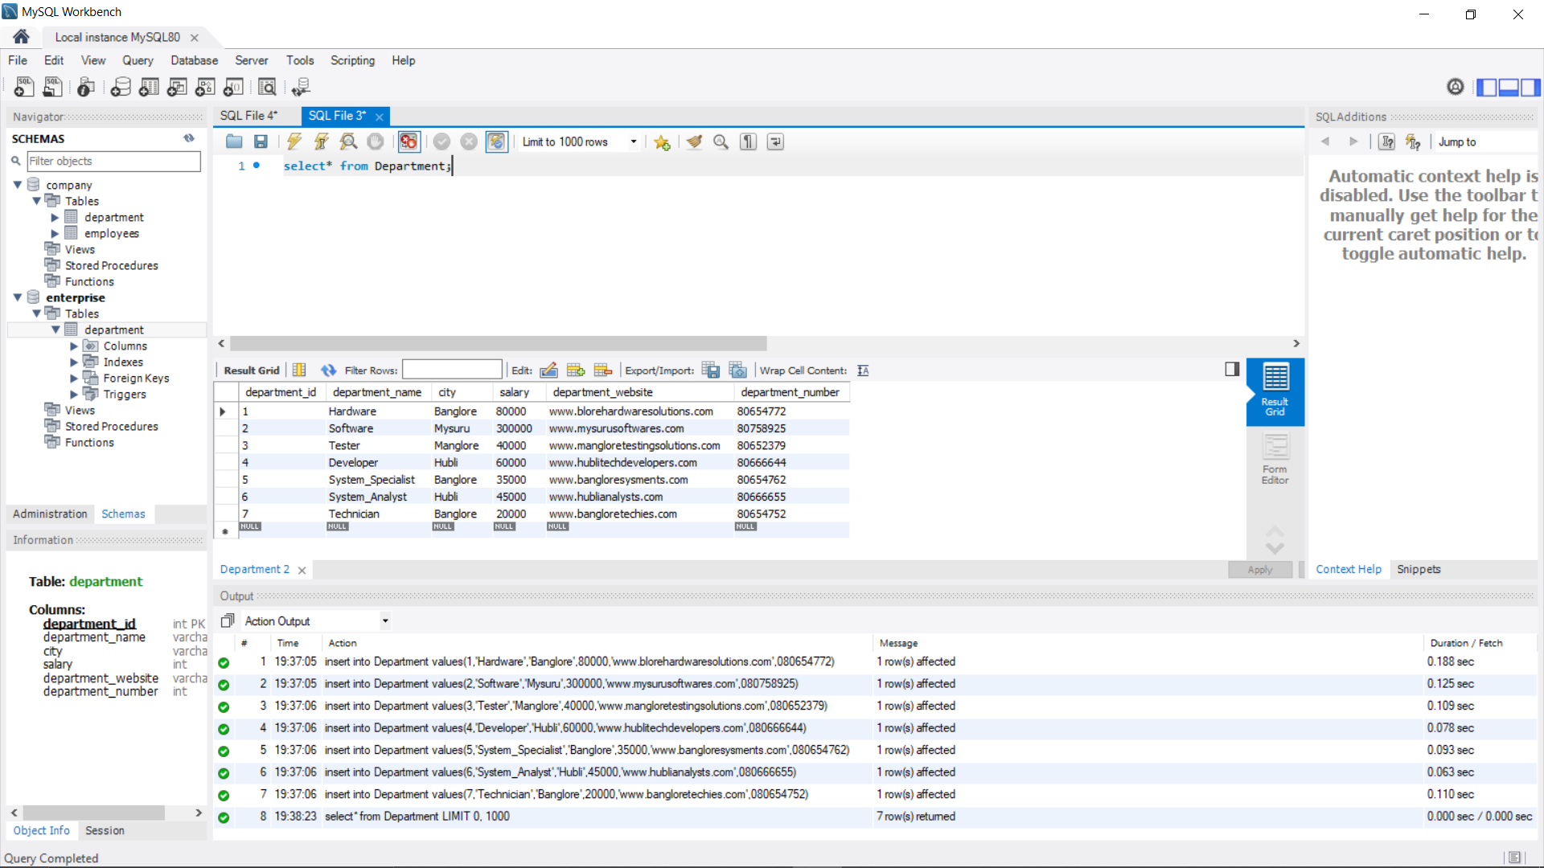

ORDER BY CLAUSE

ASCENDING ORDER

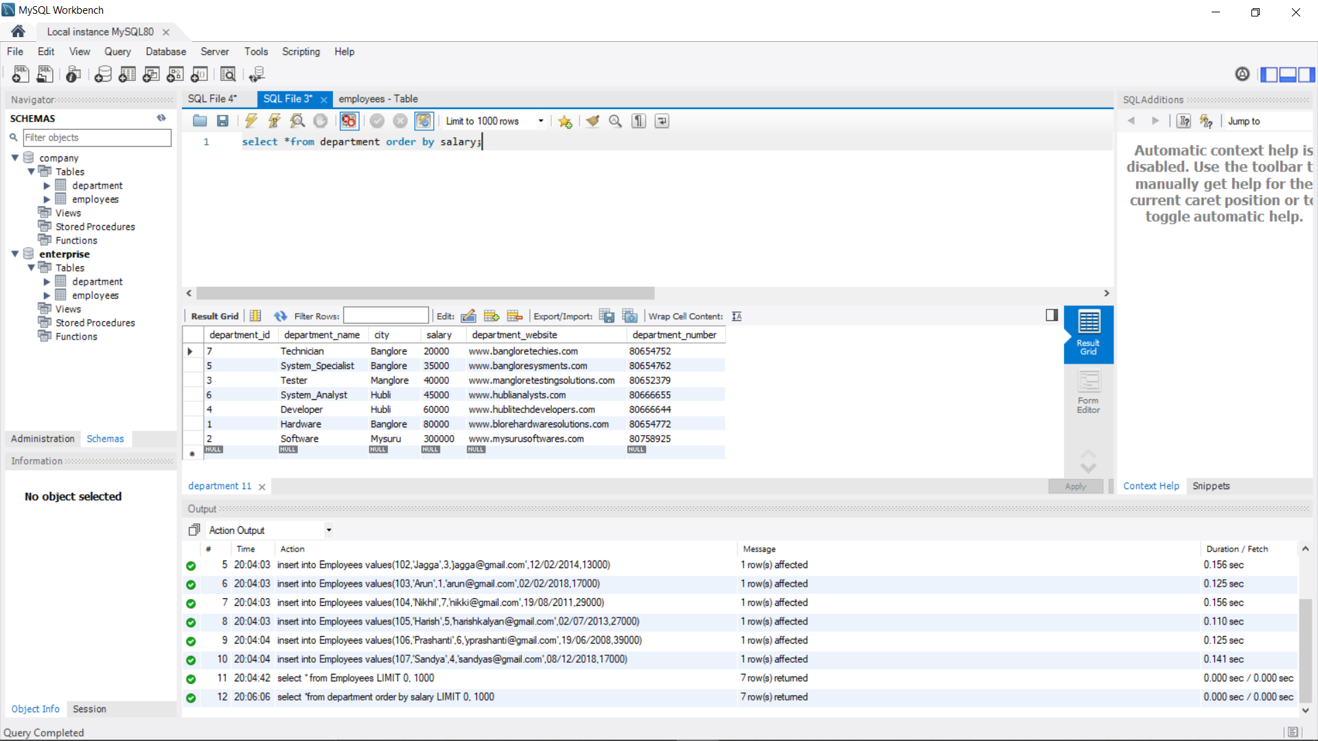

**DESCENDING ORDER**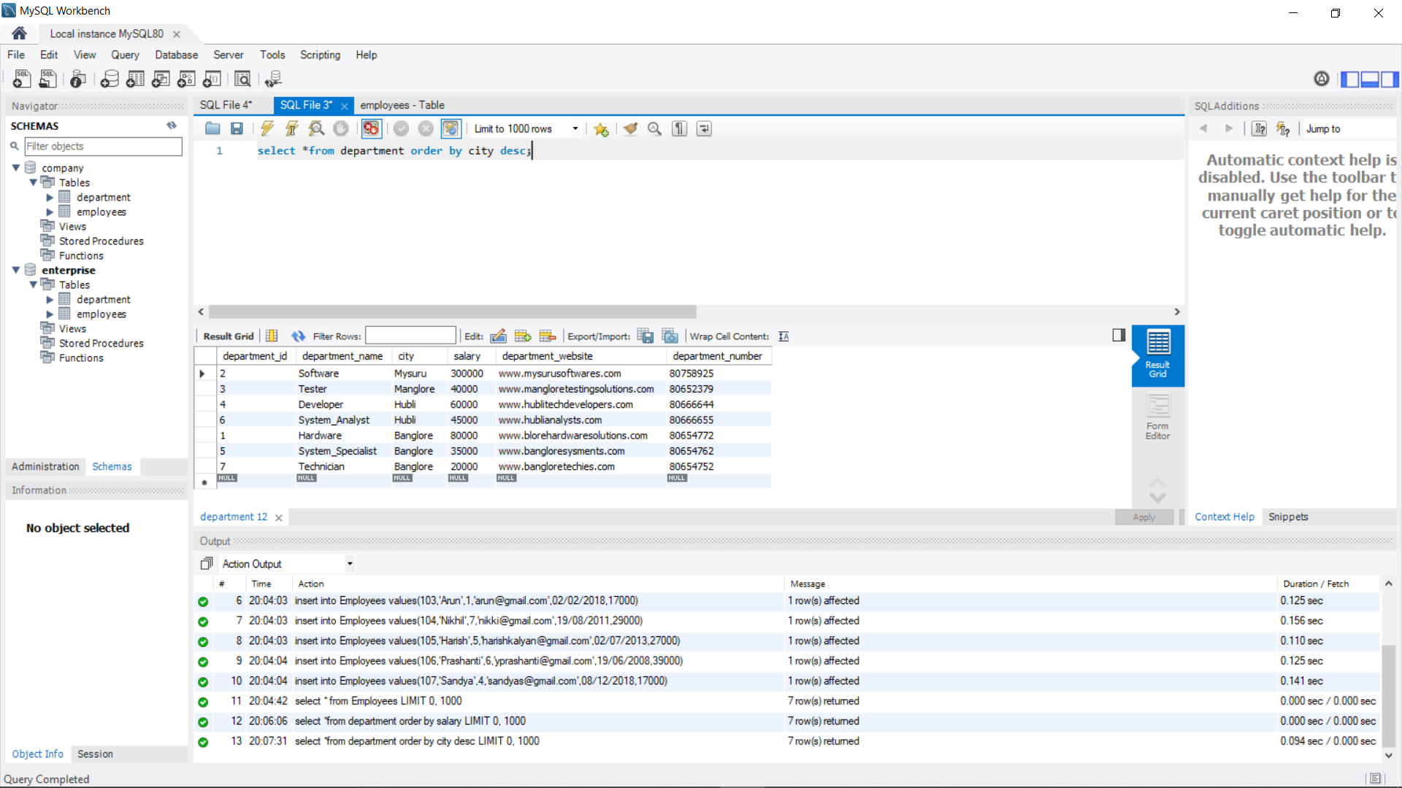

**GROUP BY**

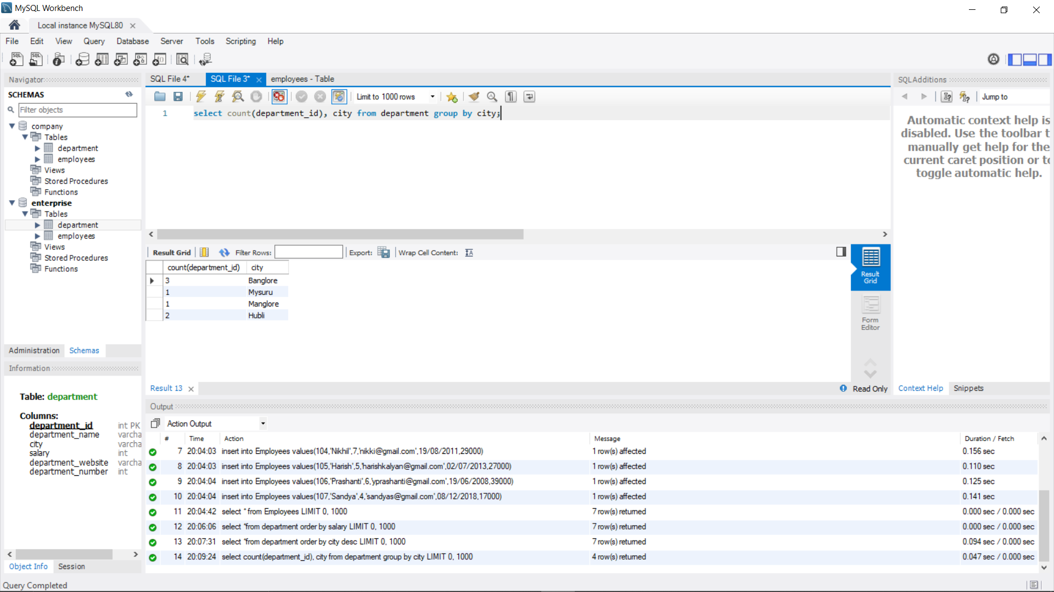

**HAVING**

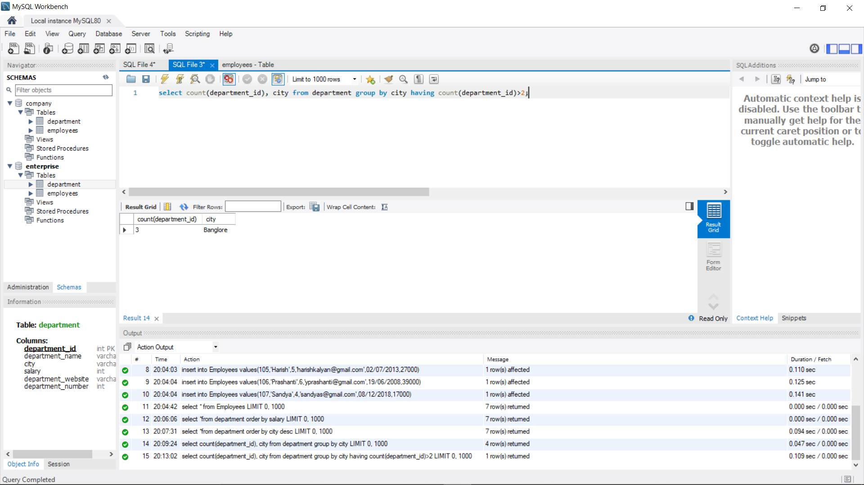

**AGGREGATE FUNCTIONS**

**MIN() FUNCTION**

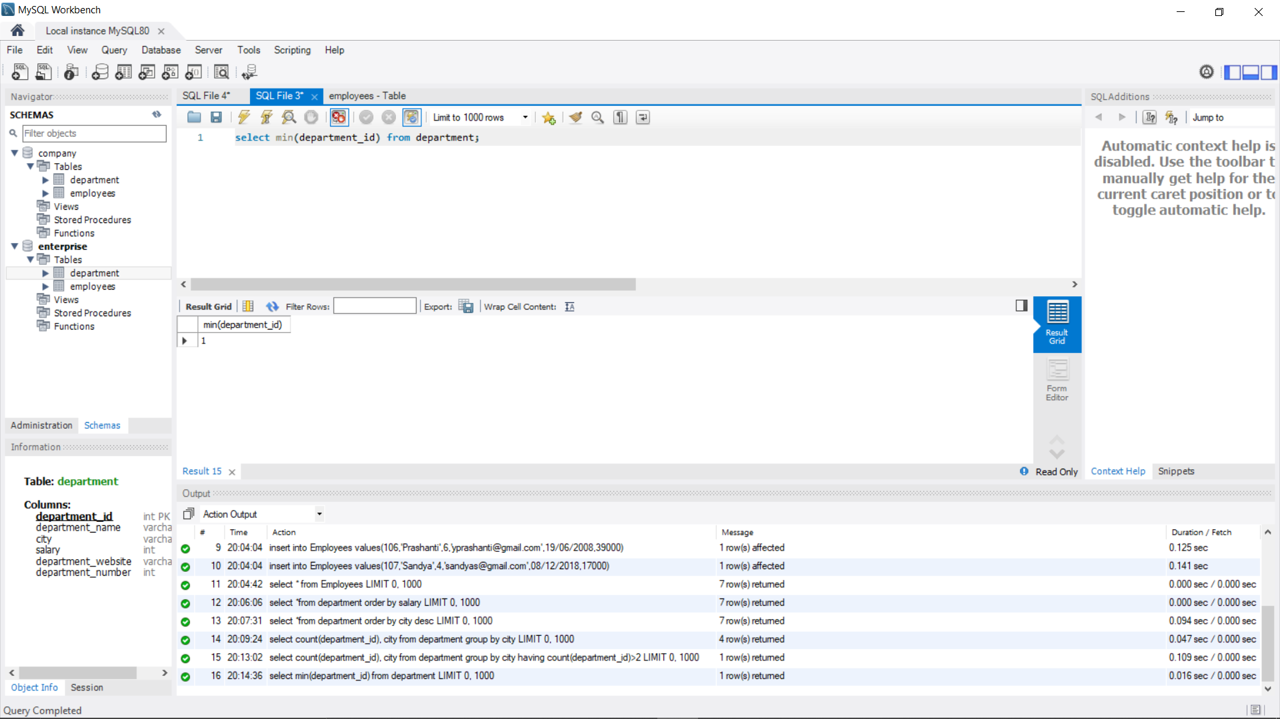

**MAX() FUNCTION**

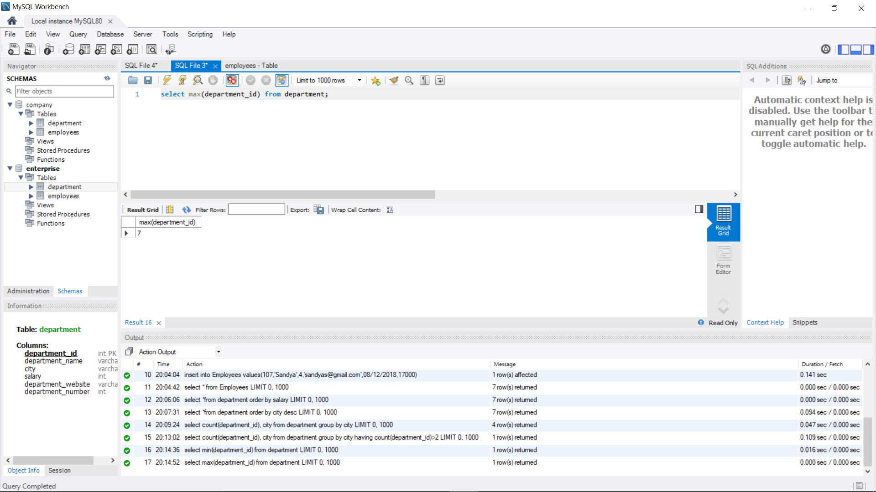

**COUNT() FUNCTION**

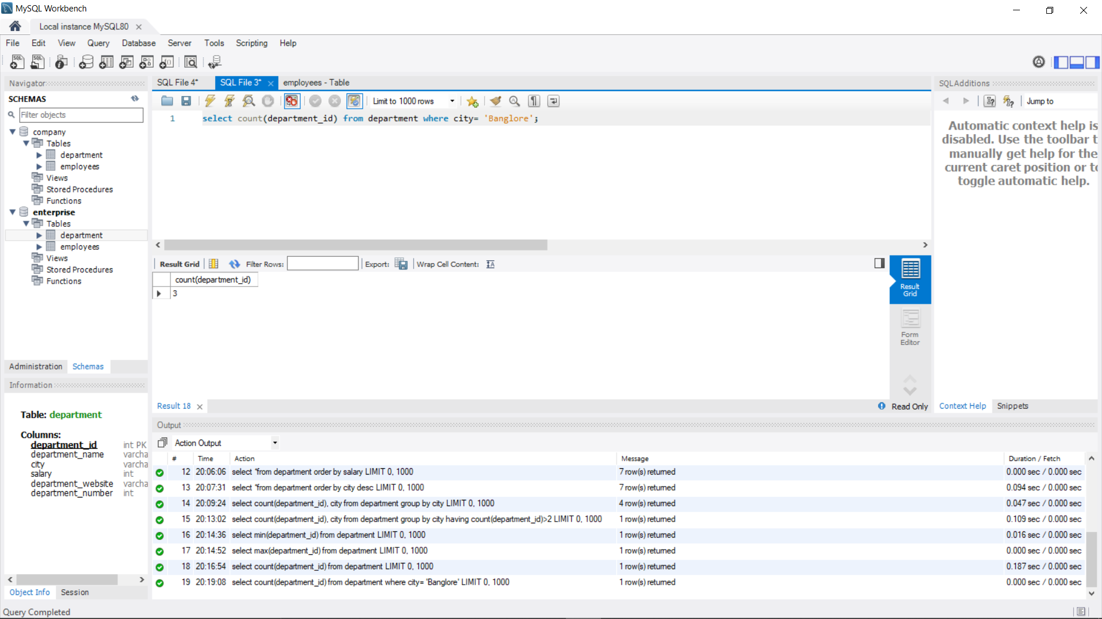

**AVG() FUNCTION**

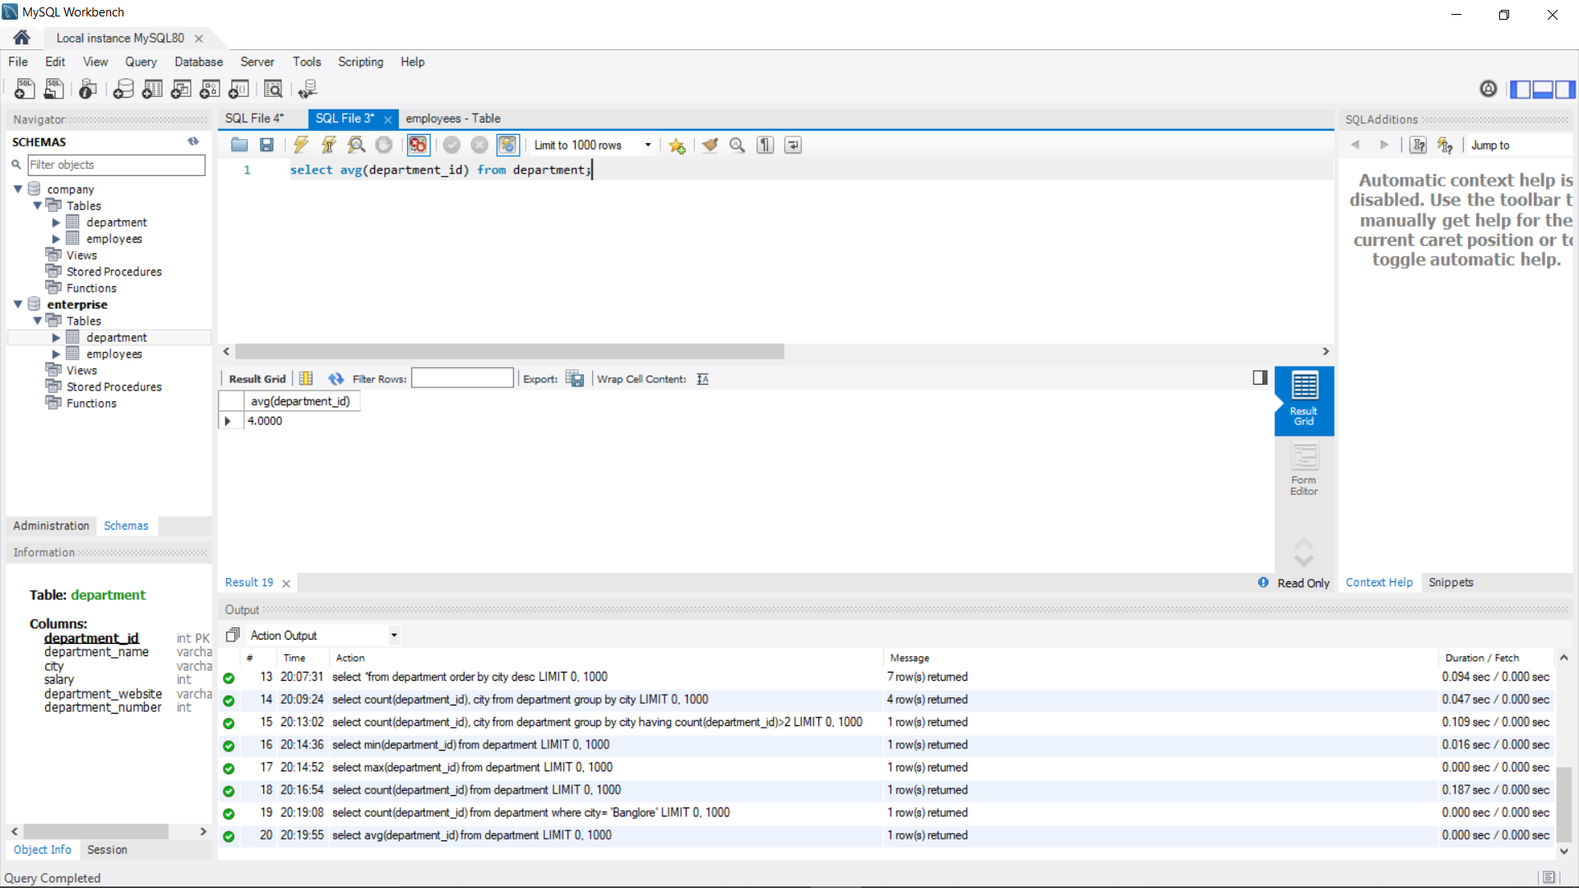

**SUM() FUNCTION**

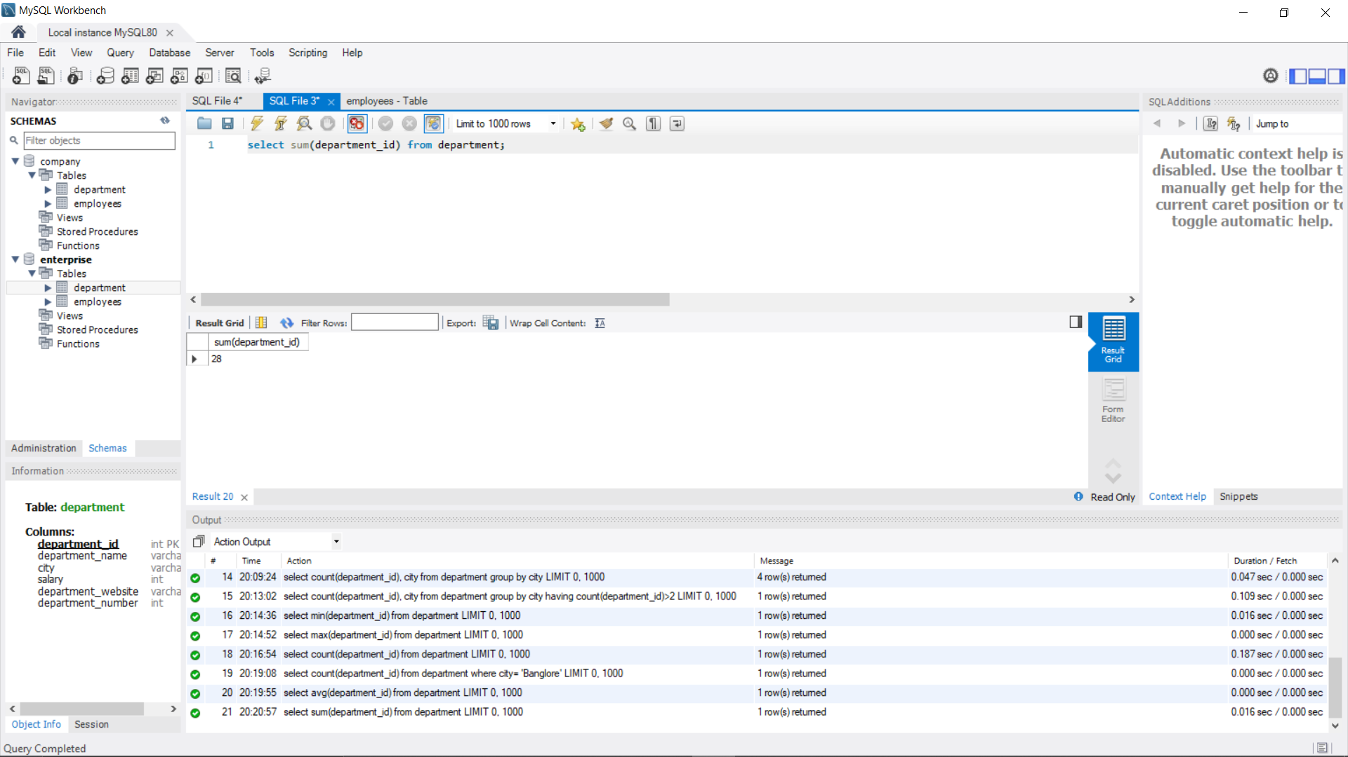

**LOGICAL OPERATORS ESPECIALLY WITH LIKE**

**‘m%’**

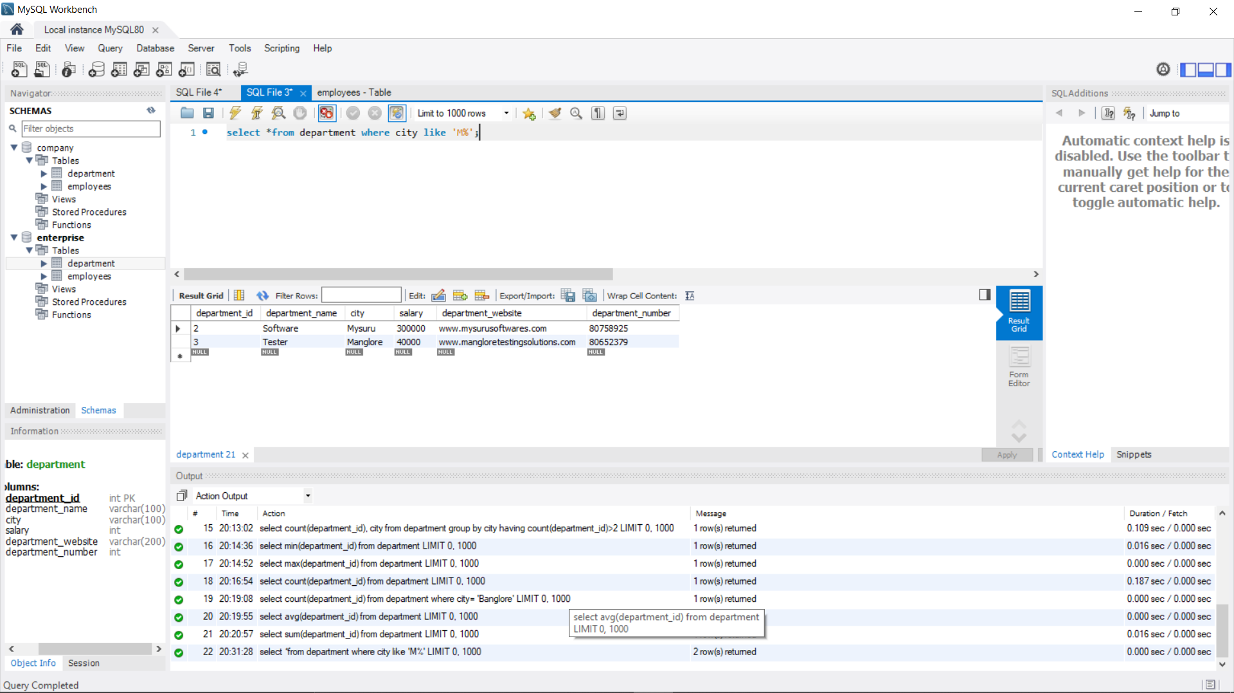

**‘%e’**

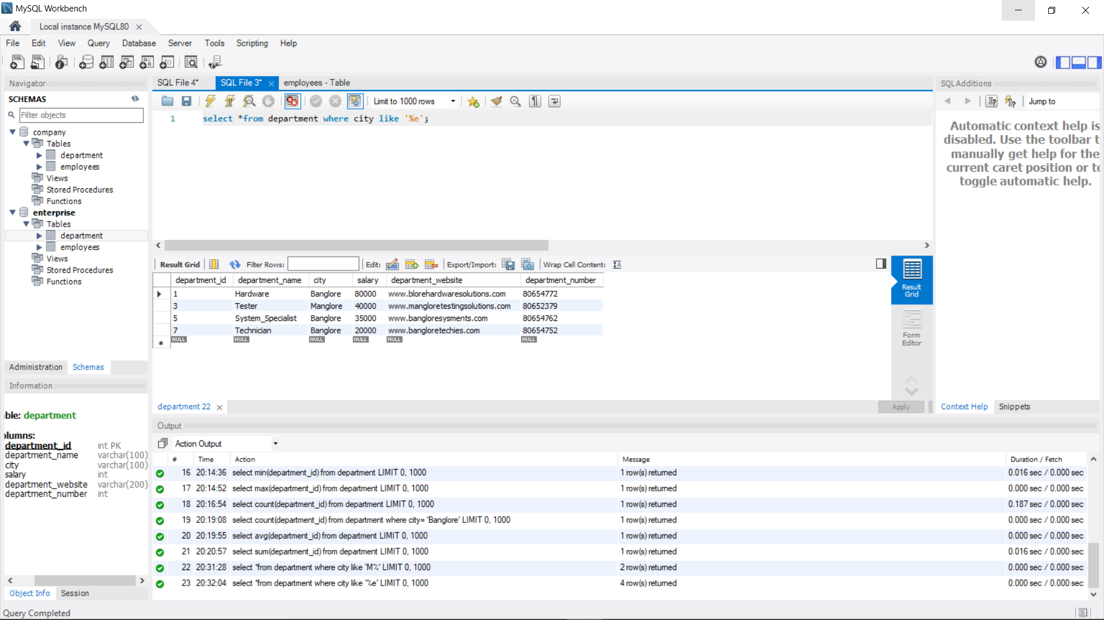

**‘_a%’**

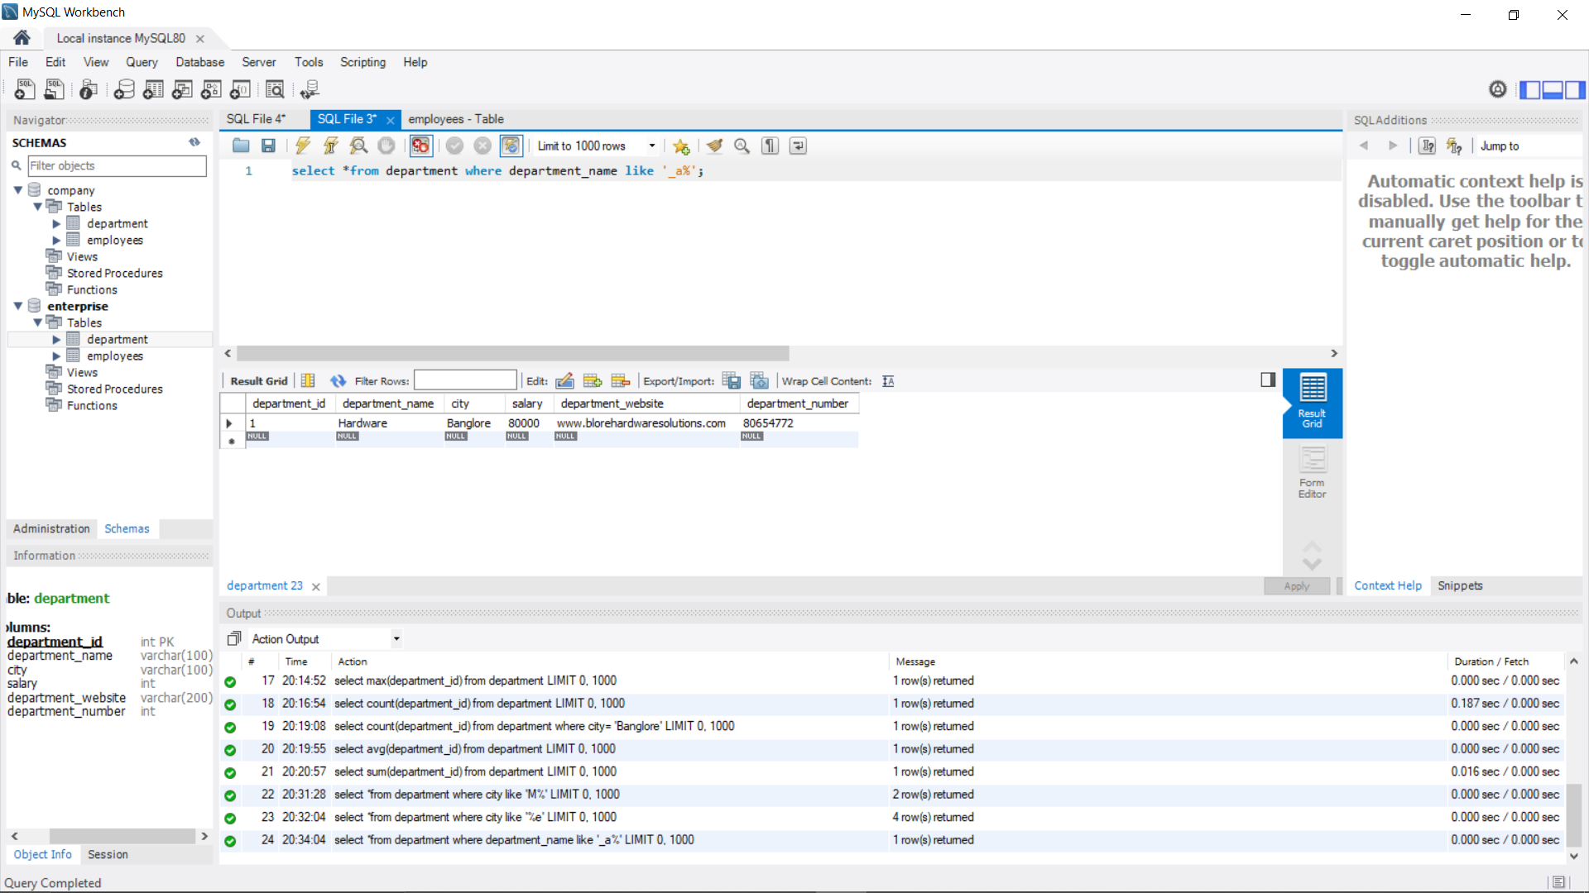

**‘b_’**

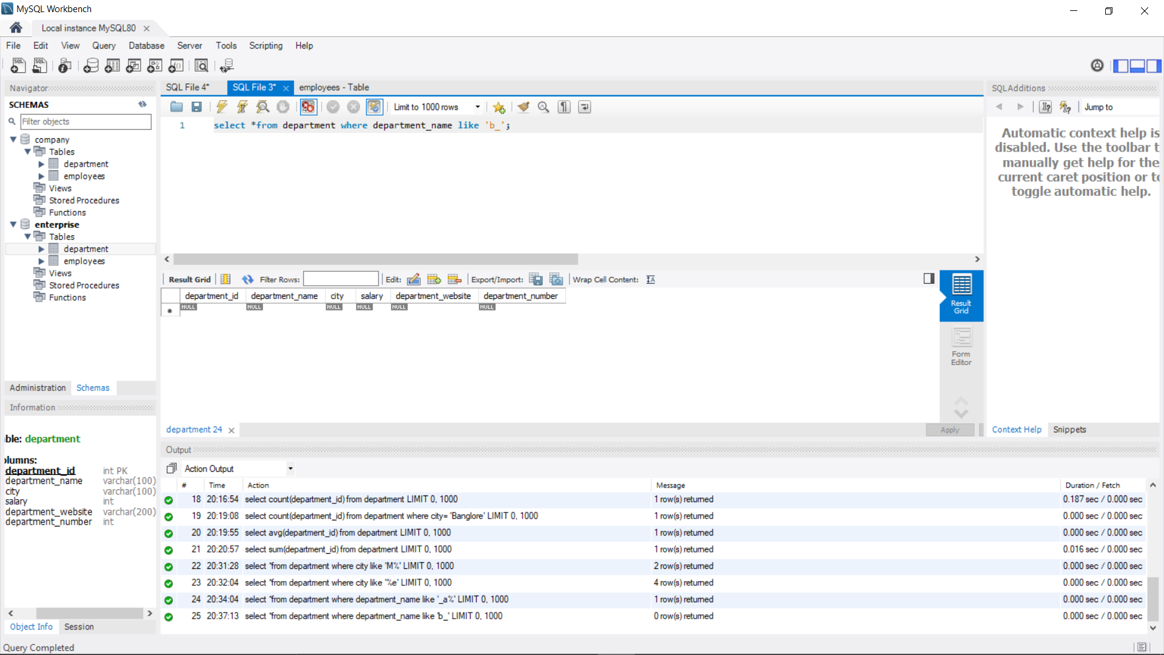

**‘b%a’**

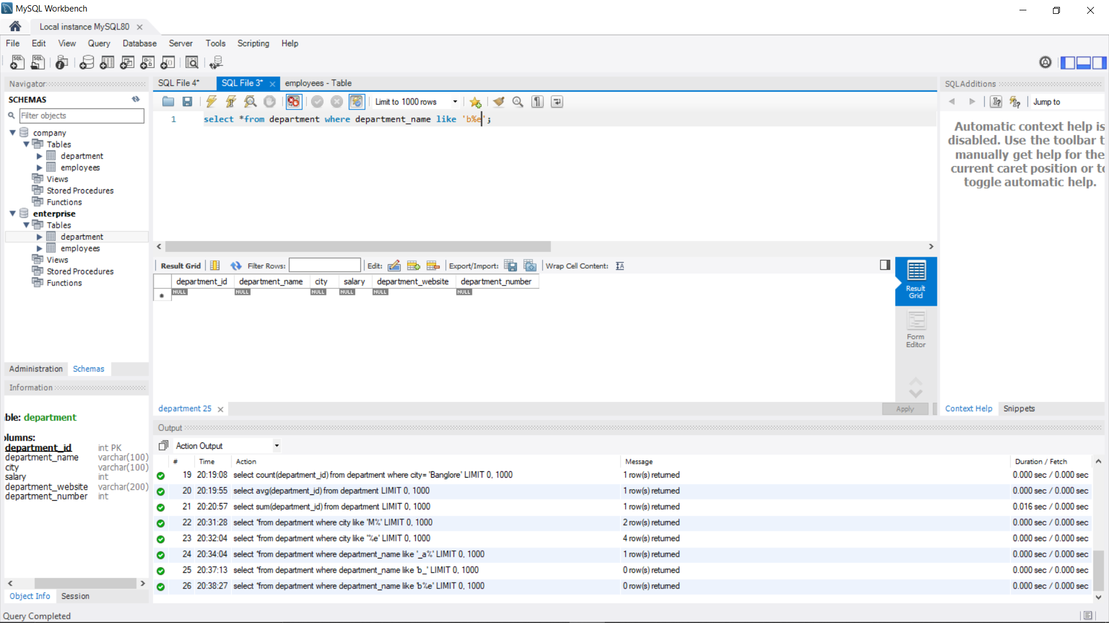

**AT LEAST 4 NESTED QUERIES SPECIFIC TO YOUR DATABASE,OUT OF WHICH AT LEAST 2 SHOULD HAVE MULTIPLE SUBQUERY**

